Render-Conceive-Stage: critical making as methods, theories, and actions.

Matt Ratto ([Matt.ratto@utoronto.ca](mailto:Matt.ratto@utoronto.ca))

Faculty of Information

University of Toronto

<http://semaphore.utoronto.ca> <http://www.criticalmaking.com>

Introduction 1

Two definitions of critical making 2

Making as Reflecting 2

Making as Intervening 4

Together now 4

Making Critical Making explicit 5

A Notional Practice 6

Conclusions 7

## Introduction

It is time to start critical making. As STS scholars, it is time for us to move beyond the linguistic and textual biases of the humanities and social sciences and engage directly with the material artifacts and systems that we study. As makers, crafters, designers, artists or engineers, it is time to move beyond propositions of instrumental or aesthetic value, to move beyond the exhibition or the demo or the one-off, and to reflect more explicitly and concretely on the relations between what things are made, how they are made, and our responsibilities for things and to things. To be clear, these dual moves are not my own, novel propositions but are situated within a number of long term projects working towards clearer articulations of what has been termed the socio-material world. Such projects are visible in a the scholarly trend in the humanities and social sciences towards the material (the so-called ‘material turn,) but are equally visible in conceptual work associated with the fields of art and design and in attempts to incorporate ‘social issues’ in engineering and other technical disciplines.

This paper is intended to act as a brief enframing and outline of work that I carry out more extensively in a book currently in process on critical making. Like this collection, the planned book is not so much a scholarly monograph as it is an instruction manual, a field guide, intended and intent-ing the reader towards action. I will provide three brief parts of the longer work; first, an expansive definition of critical making that seeks to articulate what is similar in a variety of related material-conceptual practices; second, instructions to encourage readers of this chapter to carry out a specific critical making experience that uses the Arduino system to explore concepts of morality and technology; and third, some brief conclusions on issues and needs associated with future work. The intention of this chapter is to introduce readers both materially and conceptually to hybrid engagements that take seriously the commitments associated with material semiotic theories and STS work more generally. In the remainder of this document I provide a brief outline and some example images from past engagements with the cm instructions to be included in this chapter.

## Rocks

Before you begin to read this article, please go outside and find a largish stone, though not so big that it cannot be easily lifted and carried indoors. Bring it in, and immerse it in a pail of water or under a running tap. Then place it before you on your desk – perhaps on a tray or plate so as not to spoil your desktop. Take a good look at it. If you like, you can look at it again from time to time as you read the article. At the end, I shall refer to what you may have observed. (Ingold, 2007: 1)



[Image 1: IINJGOLD – Ikea parody visual instructions, coons & Southwick]

Tim Ingold kicks off his article ‘Materials Against Materiality’ with the above instructions, encouraging readers to engage materially while simultaneously engaging discursively with his article. Like Ingold, I encourage you, the reader of this chapter to carry out his instructions and, like him, I will return to your experiences later in this piece. I do want to point out how these instructions capture what I believe is key to critical making – the hybridity of material and discursively mediated experiences and how both can act as resources for individual and social transformation.

Taking this a step further, I understand critical making to encompass a recursive relation between two modes of engagement with the material world - making oriented towards self-reflection and discovery, and making oriented towards external impact and social benefit. This relation is the pivot point around which we can highlight modes of engagement that offer up novel ways forward. The work that needs to be done regarding critical making is therefore not so much developing new practices and forms of work, but in simply revealing and highlighting modes that are already present but undervalued or even deliberately hidden. We need to describe and cultivate what is common to critical making engagements - no matter the context or ultimate goal. Whether the focus is on material intervention (such as in the work of Public Lab), exhibition and display (as in the work of critical designers), or scholarly extension and critique (as in the work of the digital humanities), all these engagements share moments where the material and the conceptual are brought together in generative ways. These moments and the development of the skills, perspectives, and ‘habits of mind’ that help instantiate them are the ultimate goal of my work.

## Two definitions of critical making

The portmanteau phrase ‘critical making’ came to me one day in 2007 while reflecting on criticality and physical production. Why was it, I thought, that the phrase critical thinking seems so obvious and correct, while the phrase critical making sounds somewhat odd? With further reflection, I realized that the term usefully elides a series of somewhat discordant meanings. By placing the emphasis on the first word, critical making, the term refers to the application of critical perspectives or thoughts to an underdescribed subject area, e.g. causing something to become or be considered critically. But by placing the emphasis on the second word, critical making, the term refers to the construction of objects intended to provide a critical perspective on some aspect of society, design, or other thematic. This ambiguity captured perfectly the mode of engagement I wanted to foster, first, the ‘making critical’ of our socio-technical lives and thereby revealing the often unseen politics of technical work and its results, and second, the idea that doing so requires forms of making itself.

Making - understood in its simplistic sense as engagements intended to transform the material environment - can therefore be understood as critical in two different ways. These are of course analytic differences, but they serve as a useful starting point for a more detailed engagement with the theory and the practice of critical making.

### Making as Reflecting

First, we can consider making as critical when the processes and activities highlight the role of material resources in both processes of discernment and in communicating the results[1]. Here, critical making can be considered as sensuous engagements where the materials in play serve as a resource for reconceptualizing the acts of production and the subjectivity of the producer. This is a well-studied phenomenon, particularly within the disciplines of Education and Cognitive Science, though often bounded, perhaps not surprisingly, by a realist ontology that focuses attention on a natural world. In other words, much - though not all - of this work remains stoutly focused on how individuals parse a natural world and the laws that govern it. In this form, critical making parallels the hermeneutic approach described by Habermas as typical of literary critical theory (cite). Critical is taken to be synonymous with reflexivity and the primary activities are those of reflection and interpretation. In this light, making is critical in so far as it allows us to interpret and understand the world. In a recent book, David Gauntlett - well-known for his pioneering work ‘Making is Connecting’ highlights precisely this focus on material production, noting that “Making things has always been a way for humans to think about things, critically and reflectively.” (Gauntlett, 2014: Making Media Studies). In the conclusion to this book, Gauntlett worries about separating critical making from everyday acts of making, concerned that “…the idea that the ‘critical’ and thoughtful version of making is something done by politically-aware professionals positioned – perhaps unintentionally – in contrast to other acts of making done by others, is unfortunate.” (126).

Gauntlett’s points are well-made - it is certainly not the case that reflexive making is only the domain of professional ‘critical makers’. The carpenter who makes a decision to use lumber from sustainable agricultural practices or the plumber who decides to use lead-free solder are both examples of everyday practices of reflexive making. From the 'tinkery business' of science (Norris, 1993) to the bricolage of Harper's 'jack-of-all-trades' (1992), detailed ethnographies of work have tended to highlight the ways material labour often involves coming to terms with local contingencies (Knorr, 1979), addressing the resistance of materials to our attempts to make use of them (Ingold,2007) while, at the same time, engaging in complex cognitive operations (Rose, 2004). In fact, some of the major outcomes of anthropologies of work have been to understand material practice as not merely the following of plans (Suchman, 1987) or as simple habitual non-cognitive action (Harper, 1987). Still, culturally, we continue to struggle with strong separations between intellectual work - often seen as happening beyond the sphere of the material world - and material labour - often depicted as a-conceptual and non-cognitive. Mike Rose, in his groundbreaking study of the intellectual aspects of manual labour writes:

It is as though in our cultural iconography we are given the muscled arm, sleeve rolled tight against biceps, but no thought bright behind the eye, no image that links hand and brain. (Rose, 2004: xiii)

So it seems more work must be done to reveal the ‘bright eyes’ as well as muscled arms of making. Insights regarding the reflexivity of making are found in both classic accounts of material work and reflexivity (e.g. Pirsig, 1974) as well as in newer articulations that focus on the value and importance of physical labour, particularly given the seemingly immaterial nature of so much modern work (e.g. Crawford, 2010). But despite the importance of such work in overcoming the simplistic platonic divides between body and mind that have troubled so much modern thought, the reconnections highlighted in these texts often seem retrospective and romantic. One reason for this may be the focus on the individual mind and singular body, with the value of reconnection being about reducing individual alienation and encouraging a kind of Maslowian self-actualization. There is, therefore, work to be done in better understanding not just the intellectual nature of material work but also how such work connects up and engages with larger conceptualizations of society. We are not just interested in reflexive making per se but in how making can help us better understand the socio-technical nature of society. The pure focus on making and its cognitive nature needs to be extended to encompass theories of knowledge, of power, and, given the technical mediation of society, the role of technoscience itself as a dominant form.

I agree therefore with Gauntlett that “…all making…can be critical making; and critical making – or, as I would call it, making – is a ‘tool for thinking’ for everybody,” (127). But I do think that the key phrase in this text is ‘can be’. Yes, all making ‘can be’ critical making - but activating this possibility requires, first, overcoming the cultural tropes and disciplinary conventions that position making as merely an instrumental, habitual, hand but not brain, activity, and second, reconnecting making to the larger social structurings that work to determine social life.

### Making as Intervening

We also understand making as critical when the intention is to transform or change the world. Here, critical making can be understood as material engagements intended to increase our understanding and ability to intervene productively in the larger socio-technical world. These forms of critical making are more directly attached to criticality in its Frankfurt School sense (Horkheimer, others) as focused on increasing the liberatory forces within modern society. If critical making in the first sense tends us towards engagements that focus on individuals and the material world, then critical making in the second sense focuses our attention outward, from the individual to the society, and asks us to think/make work that posits and performs socio-technical transformations. Engagements that use such names as ‘critical design’, ‘tactical media’, and ‘civic science’ link material practices and critical thinking in productive and insightful ways. Artist-designer-scientist-scholars such as Natalie Jerimijenko, Bill Gaver, Tony Dunne, Carl DiSalvo, Fiona Raby, Dara O’Rourke, Gwen Ottinger, Sara Wylie, Joanna Drucker, William Turkel, Phoebe Sengers, Helen Nissenbaum, Ian Bogost, Jonathan Sterne - to name just a few[2] - use material work to expand the register of scholarship on issues such as the natural and digital environment, the role of industrial design and technologies, history, science, and more. Recently, Garnet Hertz, then an Artist-in-Residence and Research Science at UC Irvine now Associate Professor at Emily Carr University, solicited contributions on the topic of ‘critical making’ from a broad range of artists and academics, including some of the people named above. He compiled these into a series of handmade critical making booklets that cover a gamut of topics from childhood to making to manifestos. The resonance of the term can be taken to indicate great interest not just in social critique and not just in the maker movement more generally, but in the conjoined material-conceptual practices shared by many of the contributors.[3]

### Together now

The different modes described above are of course analytic rather than real – most critical making activities partake of both kinds of activities, often shifting implicitly between personal reflection through making and forms of intervention through making. I believe both modes are valuable and that successful projects of either overt goal can benefit from clearer relations to the other. For example, work aimed at increasing the technical literacies of children by exposing them to coding or basic electronics (increasingly prevalent activities within public institutions such as libraries) might benefit from the kinds of social thinking that is necessary to contemplate intervention. Equally, interventionist goals can benefit from enhanced ‘thinking through’ the potentialities of the physical systems being engaged, a process where material reflection is paramount.

## The problems of critical making

Previously I believed that supporting critical making in its various forms required a kind of parsing and definitional process whereby the various ‘types’ of critical making could be described and their characteristics defined. To be sure, I still think that unpacking the various epistemic and ontological commitments of groups involved in critical making type work is still very important (see medium piece for example). But rather than work to define and separate critical making into its component practices, I think it is more necessary to assist practioners in bridging between materially-mediated reflections that are aimed inwards and material mediations that are directed outwards. The key component are theories of the socio technical that helps bridge individual material engagements with larger social organization. Not surprising this has been one goal of sts. With theory - methods such as ant scot and others focused exactly on such bridging. Other work explores this dimension medium piece, book, etc but want to call out here two things. First,  reiterate importance of this work and how necessary it is to successfully thinking through critical making; and second that there are exemplars that we can use to better define this work both materially and conceptually.

## Technoscience

Scholarly interest in fields such as Science and Technology Studies, design studies, and the digital humanities and the Maker Movement share a common interest in denaturalizing the processes and results of technoscience. Both academics and makers often share in fact, a sense that ‘it could have been otherwise’. Whereas critical scholars take this assumption as a starting point for exploring the systems of power and authority that benefit from current instantiations of technoscience, makers use it as a prompt to remake their material environments. These lines are being productively blurred by critical makers among others, including scholars such as … Such work takes seriously the concepts described as ‘material-semiotic’ (Harway, cite) and the general idea of ‘technoscience’ as defined initially by Bachelard (cite). What is often missing or understated is a theory of the socio-technical that notes the complex relations between materiality and meaning-making – the ways in which our ability to ‘socially construct’ the world through language is productively contrained/afforded by the material environment. In fact, much scholarly work has struggled with this complexity. In the natural sciences, there are typically many processes in place to try and ‘strip out’ any subjective or ‘non-natural’ aspects. This ‘purity’ work has been well described by Latour and others as the source of the ontological power of science – and its pragmatic outcomes are not to be underestimated (e.g. this is not just ‘political work.) Equally, in the social sciences and humanities, there have been similar, but opposite attempts to ‘purify’ social interactions as free from objective, material, non-humans. (find examples) But many powerful arguments in either disciplinary site attempt to incorporate both – Bohr’s work for example within the sciences, and Haraway’s work in humanities/ss.

Engaged objectivity thrives in polyphony, not in the sterile bell jar inhabited by the neutral academic observer. Genuine objectivity can only be achieved through a plurality of partial and contingent perspectives. As Donna Haraway argues, objectivity is not about disengagement but rather about “how to have simultaneously an account of radical historical contingency for all knowledge claims and knowing subjects, a critical practice for recognizing our own ‘semiotic technologies’ for making meanings, and a no-nonsense commitment to faithful accounts of a ‘real’ world” (1991, 187).8

(From Eubanks, digital dead end)

## A Notional Practice

* Exploring the material semiotic world through making
* Render-Conceive-Stage: an initial framework
* Instructions: Prompt: Build a Moral Technology (see fig 1 & 2 for examples from the related CM experience)

## Conclusions

* Review
* Institutional needs and issues

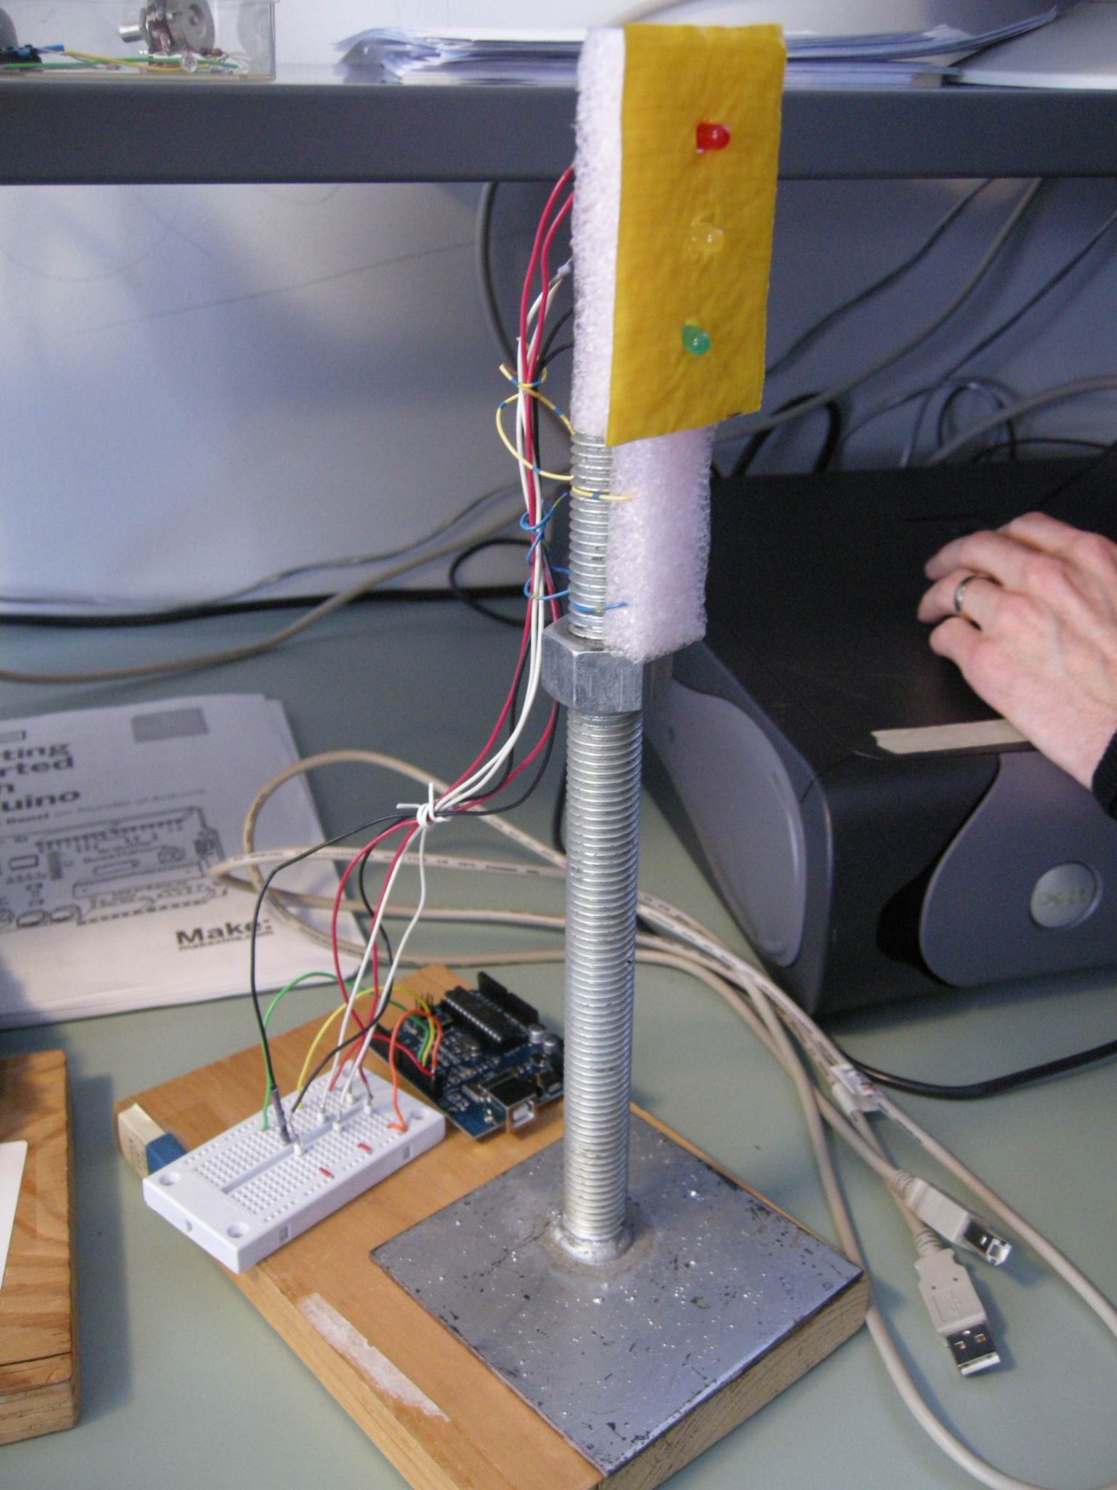

[figure 1: Traffic Signal (2009)]

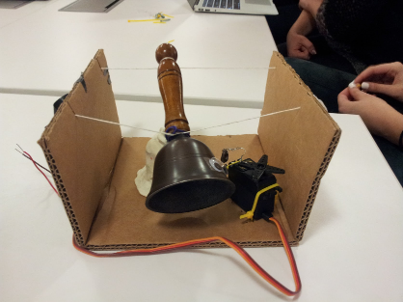

[figure 2: Bell Tolls (2012)]

1. It is misleading to distinguish critical thinking and critical making by saying that the latter involves material mediation while the former is entirely ‘mental.’ There is a diversity of work that notes the importance of material mediation in processes of cognition, including scholarship associated with Cultural Historical Activity Theory (Vygotsky, Leontiev, Engestrom, Nardi & Kaptelinin) and third-wave cognitive science of which Hutchins is a primary example (Cognition in the Wild, Hutchins, 1995) However, what differentiates critical making practices are their explicit attention to the role of the material world and the resources it provides for conceptualization and communication.
2. This list of names is not in any way exhaustive - but it is intended to represent the diversity of contexts and disciplines involved in material-conceptual practice. These include computer science, Design, STS, Law, History, Literature, Environmental Science, and Art.
3. do I need to add links here to scholars such as Mathew Fuller - media ecology, Lisa Gitelman, Parikka, Kittler? that do not do art of their own but do provide frameworks and methods for contextualizing, analysing, and relating it? think about this